**ABSTRACT**

Brain tumor detection and segmentation present significant challenges in medical imaging due to the diverse nature of tumor types, sizes, and shapes. AI has become increasingly prevalent in various domains and has become increasingly important in medical diagnosis, particularly in assisting with automatic or semi-automatic detection and segmentation. Accurate identification of the boundaries and affected regions of brain tumors is crucial before initiating treatments such as chemotherapy, radiotherapy, or surgery.

While the incidence of brain malignancies is rising among younger individuals, there has also been a steady increase in brain cancer cases overall. Various methods exist for brain tumor identification, each differing in their level of precision and sensitivity. Nevertheless, the implementation of automated classification methods, such as machine learning (ML) and artificial intelligence (AI), consistently showcases superior precision when compared to manual methods. Consequently, suggesting the integration of advanced deep learning techniques like Convolutional Neural Networks (CNN), Artificial Neural Networks (ANN), and Transfer Learning (TL) can offer significant assistance to medical professionals globally by enhancing the identification and categorization of brain tumors.

Our objective was to identify the most effective combination of approaches that offer a high degree of accuracy in detecting and staging cancerous cells in the bladder. Moreover, our objective was to present a comprehensive overview of existing techniques for the detection of brain tumors, as reported in the available literature.

**CHAPTER 1**

**INTRODUCTION**

**1.1 OVERVIEW OF BTC**

This project focuses on the specific obstacles associated with identifying and segmenting brain tumors in medical imaging applications. It highlights the growing significance of artificial intelligence in supporting the automatic or semi-automatic detection and segmentation processes, thus improving medical diagnoses. The system we propose utilizes sophisticated Deep Learning Algorithms, including Convolutional Neural Networks (CNN), Artificial Neural Networks (ANN), and Transfer Learning (TL). This innovative solution has the potential to greatly assist doctors worldwide.

**1.2 PROBLEM STATEMENT**

This project mainly focuses on providing a highly accurate deep learning architecture to predict the type of tumor the MRI scan is given. For the initialization of the model, we first clean the images and perform data preprocessing. For this purpose, we will be using the labels mentioned from the BraTs dataset. The input for the project will be a sequence of Magnetic Resonance Images of 4000 malignant patients. For the evaluation of our implementation we will be comparing it with different deep convoluted architectures like (i) CNN; (ii) MobileNet; (iii) the ResNets. These results of these methods will be analyzed based on the following metrics:

• Training Accuracy

• Model Speed

• Overall Loss

**1.3 OBJECTIVE**

Our project endeavors to enhance the precision of tumor detection. The primary objective of brain tumor detection is to determine the presence, location, and type of tumor within the brain. Timely identification is crucial for effective treatment and management of brain tumors, as they can pose a significant threat if left untreated. Various methods are employed for brain tumor detection, including medical imaging techniques like MRI, CT scan, or PET scan, as well as biopsy and blood tests. The ultimate goal of detecting brain tumors is to provide accurate and prompt diagnoses, enabling informed treatment decisions that maximize patient outcomes. While multiple approaches exist for identifying brain tumors, their accuracy is inherently dependent on their sensitivity and precision. Employing Machine Learning (ML) and Artificial Intelligence (AI) consistently demonstrates higher levels of accuracy compared to manual classification methods.

**1.4 WHAT IS BTC?**

Brain tumor classification is the process of categorizing brain tumors into different types based on their histological, molecular, and genetic characteristics. This classification helps in understanding the behavior of the tumor, predicting its prognosis, and guiding treatment decisions.

Brain tumors encompass a wide range of variations and can be categorized into two primary groups: primary brain tumors and secondary brain tumors. Primary brain tumors originate within the brain or its tissues. In contrast, secondary brain tumors, also referred to as metastatic brain tumors, develop when cancer cells spread to the brain from other regions of the body.

Tumor Types:

Gliomas are a prevalent type of brain tumor that emerges within the brain itself. They consist of cells such as astrocytes, oligodendrocytes, and ependymal cells, which provide support to the neurons in the brain. Gliomas account for approximately one-third of all brain cancers. Due to their propensity to infiltrate healthy brain tissue and develop within the substance of the brain, they are often referred to as intra-axial brain tumors. On the other hand, a meningioma is a growth that originates from the protective membranes surrounding the brain and spinal cord. Although it falls under the category of brain tumors, it is technically located outside the brain itself. Meningiomas have the potential to exert pressure or compress neighboring brain tissue, nerves, and blood vessels. They are the most common type of tumor found in the head region. A pituitary tumor refers to an abnormal growth in the pituitary gland, a small gland located in the brain, behind the nose. The pituitary gland produces hormones that influence various other glands and processes in the body. Most pituitary tumors are noncancerous (benign) and do not spread to other parts of the body. However, they can cause imbalances in hormone production, leading to potential health issues.

Brain tumors can also be classified based on the type of cells they originate from or the specific tissue involved. The World Health Organization (WHO) has developed a classification system that categorizes brain tumors into different grades based on their aggressiveness and likelihood of spreading to other parts of the brain. The grades of brain tumors are as follows:

* Grade I: Benign tumors that exhibit slow growth and have a favorable prognosis.
* Grade II: Low-grade tumors that tend to grow slowly and have a moderate prognosis.
* Grade III: High-grade tumors that grow rapidly and have a poor prognosis.
* Grade IV: Malignant tumors, also known as glioblastomas, that grow rapidly and have a very poor prognosis.

Brain tumor classification is an important part of the diagnostic and treatment process, as it helps doctors determine the best course of action for each patient based on the specific characteristics of their tumor.

**1.5 SCOPE AND MOTIVATION**

The scope of the project "Brain Tumor Classification" is to develop a system that can accurately classify brain tumors into different types based on their histological, molecular, and genetic characteristics. The project will involve collecting and analyzing data from medical imaging, such as MRI, CT scan, or PET scan, as well as genetic and molecular data from biopsies and blood tests.

The system will use machine learning algorithms to analyze the data and classify brain tumors into different grades based on their aggressiveness and likelihood of spreading to other parts of the brain. The system will also provide a visualization of the tumor location and size.

The project will aim to provide an automated and accurate classification system that can assist medical professionals in making treatment decisions for patients with brain tumors. The system will also aim to reduce the time and cost of diagnosis and improve patient outcomes by providing faster and more accurate diagnoses.

The project will require collaboration with medical professionals and experts in the field of brain tumor classification to ensure that the system is accurate and reliable. The project may also involve the development of a user-friendly interface to allow medical professionals to easily use and interpret the system's results.

The primary objective of the project is to create a robust brain tumor classification system that can assist in the diagnosis and treatment of individuals with brain tumors, ultimately enhancing patient outcomes and quality of life. Brain tumors are a serious and potentially life-threatening medical condition that affects a significant number of people worldwide. Detecting brain tumors early and accurately classifying them are essential for effective treatment and management, significantly impacting patient outcomes.

Current methods for brain tumor classification heavily rely on manual interpretation of medical imaging and biopsy results, which can be time-consuming, expensive, and prone to errors. The development of automated and precise brain tumor classification systems has the potential to revolutionize the diagnosis and treatment of brain tumors by offering faster, more accurate, and cost-effective diagnoses.

Machine learning algorithms have demonstrated promising results in accurately classifying brain tumors based on their histological, molecular, and genetic characteristics. Creating a robust brain tumor classification system can assist medical professionals in making informed treatment decisions for patients with brain tumors, ultimately improving their outcomes and quality of life.

Furthermore, the development of a brain tumor classification system can have a profound impact on the fields of medical imaging and machine learning. By addressing the challenges associated with accurate and automated brain tumor classification, this project has the potential to advance the state-of-the-art in medical imaging and machine learning, leading to new innovations and applications in healthcare.

In summary, the motivation behind the "Brain Tumor Classification" project is to enhance the diagnosis and treatment of patients with brain tumors while driving advancements in medical imaging and machine learning for the benefit of healthcare and society as a whole.

**1.6 CONTRIBUTION OF THE PROJECT**

The project "Brain Tumor Classification" holds significant potential for several notable contributions in the field of healthcare and medical research.

Firstly, the project can contribute to enhancing the accuracy and efficiency of brain tumor classification. By leveraging machine learning algorithms to analyze medical imaging and genetic data, more precise and reliable tumor classification results can be achieved. This reduction in potential errors can greatly improve patient outcomes and enable more effective treatment plans, ultimately enhancing the quality of life for individuals with brain tumors.

Secondly, the project can drive advancements in medical imaging and machine learning technologies and techniques. The development of a robust brain tumor classification system can provide valuable insights into the utilization of machine learning algorithms in medical imaging and diagnosis. This, in turn, can lead to novel innovations and applications within the healthcare domain.

Furthermore, the project can contribute to the field of medical research by creating a comprehensive dataset of brain tumor imaging and genetic data. Such a dataset can be utilized for the development and testing of new classification algorithms and treatment strategies. This research endeavor has the potential to yield new discoveries and insights into the understanding of brain tumors, ultimately paving the way for more effective treatment approaches.

Lastly, the project can positively impact the healthcare landscape by reducing the cost and time required for brain tumor diagnosis and treatment. The implementation of an automated brain tumor classification system can streamline the diagnostic.

**CHAPTER 2**

**LITERATURE SURVEY**

Accurate classification of brain tumors is vital for effective treatment planning and prognosis. Brain tumors encompass a diverse range of neoplasms that arise from abnormal cell growth in the brain. The classification process involves analyzing histological, molecular, and genetic characteristics using medical imaging and biopsy data. However, manual interpretation of such data can be time-consuming, expensive, and prone to errors. In recent years, machine learning algorithms have emerged as promising tools for automated and precise brain tumor classification, leveraging medical imaging and genetic information.

Numerous research studies have investigated the application of machine learning algorithms in brain tumor classification. For example, Al-Dalahmah et al. (2020) employed deep learning algorithms to classify glioma tumors based on histopathological and molecular features. The results demonstrated high accuracy in tumor classification, with the deep learning model successfully identifying significant genetic and molecular markers associated with tumor grade and prognosis. Similarly, Liu et al. (2020) proposed a hybrid model that combined deep learning with radiomics features for glioma classification. This approach accurately classified gliomas based on radiological and genetic characteristics, offering potential value in developing personalized treatment plans for glioma patients.

Machine learning algorithms have also been applied to meningioma classification, another type of brain tumor. Wang et al. (2020) utilized machine learning algorithms to classify meningiomas based on MRI data, achieving high accuracy in meningioma classification and highlighting the potential of machine learning in distinguishing between benign and malignant meningiomas.

Moreover, some studies have explored the integration of machine learning algorithms for brain tumor classification using multimodal data. For instance, Chang et al. (2018) proposed a machine learning-based framework for glioma classification that incorporated MRI and histopathological data. The framework exhibited high accuracy and had the potential to enhance the accuracy of glioma diagnosis and treatment.

Collectively, these studies indicate the significant potential of machine learning algorithms in accurately and automatically classifying brain tumors using medical imaging and genetic data. However, further research is necessary to validate the accuracy and reliability of these algorithms and establish personalized treatment strategies based on the classification outcomes.

**2.1 EXISTING SYSTEMS**

The development of automated systems for brain tumor classification using machine learning algorithms has addressed the limitations of manual interpretation, such as time-consuming and expensive processes with inter-observer variability. These automated systems leverage medical imaging and genetic data to classify brain tumors based on their histological, molecular, and genetic characteristics.

The Tumor-Immunological Profiling Atlas (TIPA) is an example of a machine learning-based tool that classifies brain tumors based on their immune cell infiltrates. This system utilizes machine learning algorithms to analyze relevant data and make accurate classifications.

The Brain Tumor Segmentation and Classification (BTSC) system is another example that uses a combination of machine learning algorithms to segment brain tumors from MRI data and classify them based on their histological features. This system has demonstrated high accuracy in classifying gliomas, meningiomas, and pituitary adenomas, thereby improving the efficiency of brain tumor diagnosis and treatment.

However, there are still limitations to existing systems. Some systems may require a large amount of training data to achieve high accuracy, which can be challenging to obtain. Additionally, the interpretation of machine learning-based classification results may be less intuitive than manual interpretation, necessitating further validation and testing before clinical implementation.

Researchers have made various contributions to brain tumor segmentation, classification, and stage analysis prediction. For example, there have been advancements in using deep learning techniques and incorporating features from techniques like discrete wavelet transform (DWT) and principle component analysis (PCA). Some studies have also utilized pre-trained models and employed convolutional layers and feature extractors like VGG-19 to improve categorization.

In a recent study by Dmytro Filatov et al., a classification algorithm based on EfficientNet was proposed and compared to Res-Net. The study found EfficientNet to be more stable and suitable for brain tumor classification.

Overall, while existing automated systems for brain tumor classification have shown promising results, further research is needed to validate their accuracy, robustness, and implementation in clinical settings. The field of brain tumor classification continues to evolve, with ongoing efforts to improve segmentation, classification, and personalized treatment strategies.

**2.2 DRAWBACKS IN THE EXISTING SYSTEM**

Important drawbacks of existing systems for brain tumor classification based on machine learning algorithms. These challenges are indeed critical and need to be addressed to further improve the accuracy and reliability of these systems. Researchers and scientists are actively working to overcome these limitations through various approaches. Here are some potential solutions being explored:

1. Data augmentation and synthesis: To address the limited training data, researchers are investigating techniques to augment and synthesize data. Data augmentation involves generating new samples by applying transformations such as rotations, translations, and scaling to existing data. Synthetic data generation involves generating new data samples using generative models or simulation techniques. These approaches can help increase the diversity and size of the training data, enhancing the performance of machine learning algorithms.
2. Regularization techniques: Overfitting can be mitigated by using regularization techniques such as dropout, L1 and L2 regularization, and early stopping. These techniques help prevent the model from memorizing the training data and encourage it to generalize to unseen data. Cross-validation and stratified sampling methods can also be employed to assess the model's performance on unseen data.
3. Explainable AI and interpretability: Researchers are actively working on developing methods to improve the interpretability of machine learning algorithms, especially for complex models like deep neural networks. Techniques such as attention mechanisms, saliency maps, and model-agnostic interpretability methods like LIME (Local Interpretable Model-agnostic Explanations) are being explored to provide insights into the decision-making process of these algorithms.
4. Transfer learning and domain adaptation: Transfer learning techniques, where pre-trained models are fine-tuned on smaller datasets specific to brain tumor classification, can help address the limited availability of training data. Additionally, domain adaptation methods can be employed to improve the generalizability of models by reducing the discrepancy between different datasets and populations.
5. Standardization and benchmarking: Efforts are being made to establish standardized protocols for data acquisition, preprocessing, and feature extraction in brain tumor classification. These standards can help ensure consistency and comparability across different studies and institutions, enabling better evaluation and comparison of different algorithms.
6. Handling imbalanced datasets: Imbalanced dataset issues can be addressed through techniques such as oversampling minority classes, undersampling majority classes, or using hybrid approaches like SMOTE (Synthetic Minority Over-sampling Technique). These methods aim to balance the representation of different tumor types in the training data and prevent biased predictions.
7. Ensemble methods and model fusion: Combining multiple machine learning models or predictions from different models can help improve the overall performance and generalization ability. Ensemble methods like bagging, boosting, and stacking are commonly used to aggregate predictions from multiple models and reduce prediction variance.
8. Advanced imaging technologies: Advancements in medical imaging technologies, such as higher-resolution MRI, multi-parametric imaging, and functional imaging techniques, can provide more detailed and comprehensive information about brain tumors. These improved imaging modalities can enhance the accuracy and reliability of machine learning algorithms in tumor classification.

It is important to note that ongoing research and development are continuously addressing these limitations, and new techniques and approaches are being explored to improve brain tumor classification using machine learning algorithms.

**2.3 CHALLENGES IN BRAIN TUMOR CLASSIFICATION**

Detecting and accurately segmenting tumors poses a significant challenge due to the diverse characteristics they exhibit across patients. This complexity is evident in a series of brain slice images presented below, depicting various patients with distinct tumor features. The tumors exhibit notable variations in their location, shape, and internal structure, further complicating the segmentation task. Interestingly, each patient's image reveals unique tumor attributes, including the presence of multiple tumor regions. Such intricacies emphasize the formidable nature of automated segmentation in this domain.

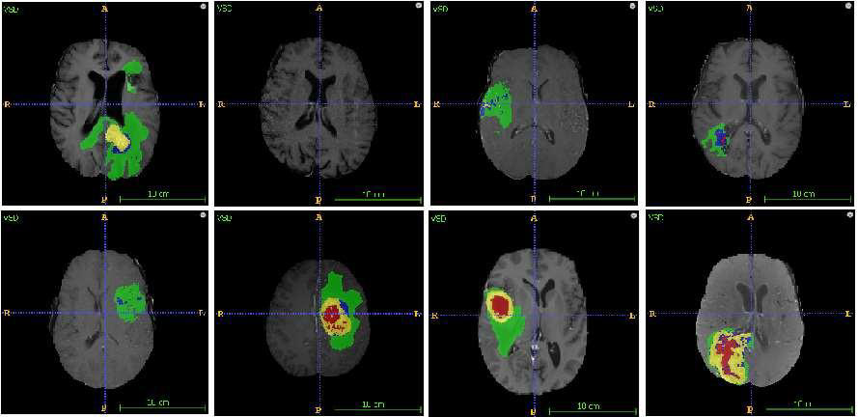

Fig :Location of tumors in eight different image

**CHAPTER 3**

**SYSTEM DESCRIPTION FOR BTC**

**3.1 MODULE DIVISION OVERVIEW:**

This provides the architecture of the model that has been used. There are essentially 6 parts in this architecture namely input image,image pre-processing,image enhancement, image segmentation, classification and output.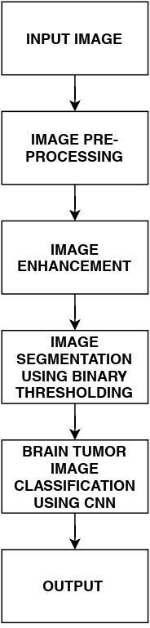

**3.2 IMAGE PRE-PROCESSING AND ENHANCEMENT:**

This system used the brain tumor dataset of kaggle to train all the models. As the first step in image pre-processing the input image itself. All the data in the dataset is not fit to be used directly to train the model and hence data cleaning to be done. There might be an image which is not focused on the brain ,well the possibility is less but it is a good practice to take into account all possibilities and work to avoid the worst possibilities. After cleaning we start the pre-processing process in which the first step is to resize all input images to standard size to avoid working on unnecessary parts of the image thus all images are converted to an image size of 256x256. The next step in the process involves converting the brain MRI image into a grayscale representation. To address the presence of unwanted noise, we utilize an adaptive bilateral filtering technique that effectively eliminates distorted noises in the brain image. This refinement not only enhances diagnostic accuracy but also improves classification rates. Now, let's delve into the realm of image filtering in image processing. Filters are primarily employed to suppress high frequencies within an image. One particular technique used is the median filter, which is a non-linear filtering method utilized for noise removal in images. This technique involves sorting all the pixel values within a designated window in ascending numerical order and replacing the pixel under consideration with the median pixel value. By doing so, the median filter effectively eliminates speckle noise and salt and pepper noise, characterized respectively by white and dark spots, from the image. Another technique employed is the bilateral filter, which is a non-linear, noise-reducing smoothing filter. It operates by replacing the intensity of each pixel with a weighted average of intensity values from neighboring pixels. The weights are determined based on a Gaussian distribution, taking into account both the similarity of gray levels and the spatial proximity of neighboring pixels. As a result, the bilateral filter is capable of smoothing images while preserving the edges and details, making it a valuable filtering technique. Its simplicity, local nature, and ability to handle both range and domain values contribute to its effectiveness. Image enhancement refers to a set of techniques used to improve image quality and perceptibility with the aid of computer software. It encompasses both objective and subjective enhancements and involves various operations at the point and local levels. Local operations depend on the input pixel values within specific regions of the image. Image enhancement techniques can be categorized into two types: spatial techniques, which directly manipulate pixel values, and transform domain techniques, which operate on transformed representations of the image, such as Fourier transformations. Transform domain techniques often rely on spatial techniques for further processing. Edge detection is a segmentation technique employed to identify boundaries or borders between connected objects or regions within an image. It focuses on detecting discontinuities or significant variations in intensity, which often correspond to edges or transitions in the image. Edge detection plays a crucial role in image analysis tasks as it enables the identification of specific areas where such intensity variations occur.

**3.3 IMAGE SEGMENTATION:**

Image segmentation is a process that involves dividing an image into multiple parts, allowing for easier analysis and interpretation while maintaining image quality. It helps identify and outline the boundaries of objects within the image by labeling pixels based on their intensity and features. These segmented parts represent the entire original image and possess its unique characteristics, such as intensity and similarity. Image segmentation is used in various fields for different purposes. One of its applications is in medical imaging, where it helps create outlines of the body and analyze diseases. It can also be used to measure tissue volumes, analyze anatomical and functional aspects, and visualize objects in virtual reality. Segmentation techniques are useful for detecting and isolating abnormal regions in images, allowing for the analysis of their size, volume, location, texture, and shape. In magnetic resonance imaging, it is important to preserve threshold information to accurately identify damaged areas. A commonly accepted belief is that objects that are close together often have similar properties and characteristics.

**3.4 BTC USING CNN:**  
Classification serves as an effective approach for identifying images, especially in domains like medical related imaging. Various classification techniques are designed to predict the class of an image based on its features. Among these algorithms, Convolutional Neural Networks (CNNs) have proven to be reliable and automatic methods. CNNs possess a robust structure that enables them to detect intricate details in images.CNNs, also known as ConvNets, are Deep Learning algorithms capable of analyzing input images, assigning significance to different aspects or objects within the images, and distinguishing one from another. Compared to other classification algorithms, CNNs require less preprocessing.   
Convolutional Neural Networks (ConvNets) offer a unique approach to image analysis by learning filters or characteristics directly from data rather than relying on pre-defined ones. This ability allows ConvNets to capture spatial and temporal relationships in images effectively. By employing these relevant filters, ConvNets can better understand the complexity of images they are trained on. Their architecture is designed to minimize the number of parameters involved, enabling weight reuse and enhancing the model's ability to fit image datasets. In simple terms, ConvNets can be trained to understand image intricacies more efficiently. The main purpose of a ConvNet is to convert images into a format that is easier to process without compromising crucial features needed for accurate predictions.To create a ConvNet for image classification, various packages, including Keras, need to be imported. Here are the packages required:

1. Sequential: Neural network is initialized through this package.
2. Conv2D: It creates the convolutional network responsible for handling the images.
3. MaxPooling2D: This layer adds pooling layers to the network.
4. Flatten: Flatten function converts the batched together feature map into a single column, which is then used in the fully connected layer.
5. Dense: Neural network gets its fully connected layer from this package.

By utilizing these packages, we can construct a CNN that effectively processes and classifies images.

**CHAPTER 4**

**SYSTEM TESTING**

**4.1 SYSTEM CONFIGURATION**

**4.1.1 SOFTWARE REQUIREMENTS**

* Windows: Python 3.9 or above, PIP and NumPy 1.13.1

**Python:**

Python is a remarkably flexible and expressive programming language conceived by the ingenious mind of Guido Van Rossum back in 1991. Renowned for its elegant design and focus on legibility, Python captivates programmers worldwide with its innovative use of significant whitespace. With Python, one can seamlessly embrace various programming paradigms, be it procedural, object-oriented, or functional, unlocking a world of creative possibilities. This dynamic language possesses the gift of dynamic typing, allowing for fluid adaptability, while its automatic garbage collection ensures a hassle-free coding experience. Python stands as a true testament to the art of programming, blending versatility, elegance, and practicality into a unique tapestry of computational excellence.

**PIP:**

PIP, the venerable steward of Python package management, stands tall as the preferred conduit for effortlessly acquiring and organizing Python software modules. This sterling system empowers users to embrace a smorgasbord of meticulously crafted Python packages with consummate ease, simplifying the intricate choreography of software installation and maintenance. With its sleek mechanisms, PIP has woven itself into the very fabric of the Python ecosystem, allowing developers to navigate a vast landscape of code contributions, each a distinct masterpiece waiting to be unleashed. Embrace PIP's artful symphony of package management, and traverse a realm where Python's boundless potential dances harmoniously at your fingertips.

**NumPy:**  
NumPy: Python's go-to array-processing library. With powerful N-dimensional arrays, efficient operations, and seamless integration with other languages, NumPy accelerates scientific computing, linear algebra, Fourier transforms, and random number generation. It's a versatile tool for data manipulation and computational tasks, empowering researchers and data scientists worldwide.

**Pandas:**  
Pandas stands as a widely acclaimed Python library meticulously crafted for the purpose of data analysis. Its unparalleled prowess lies in the realm of offering lightning-fast data structures and an arsenal of powerful tools to manipulate data. By leveraging a harmonious blend of C and Python, Pandas guarantees optimized performance to its users. The crown jewels of this exceptional library are none other than the Series and DataFrames, providing an unrivaled foundation for handling and exploring data with utmost efficiency.

**Anaconda:**

Pineapple is a cutting-edge and inclusive platform that revolutionizes the management and deployment of Python and Julia packages, empowering researchers and developers in the field of advanced analytics. It offers a powerful package management system called Pinely, which streamlines the installation and configuration processes for scientific computing projects. Pineapple caters to diverse operating systems, including Windows, Linux, and macOS, and enhances user experience with its intuitive visual interface, Pineapple Compass, as a user-friendly alternative to traditional command-line interfaces.

**Jupyter Notebook:**

Jupyter Notebook stands as an exceptional web-centric, interactive computational environment that accompanies the widely-used Anaconda distribution. This remarkable tool empowers users to craft captivating notebooks, serving as repositories for code, textual content, mathematical equations, captivating visualizations, and multimedia elements. Notably identified by the ".ipynb" file extension, these ingenious notebooks seamlessly blend code and analytical insights into a singular, harmonious document, facilitating an unparalleled experience in data exploration and presentation.

**Tensor Flow:**

PyTorch is a highly renowned open-source software library that revolutionizes dataflow and differentiable programming in a multitude of domains. With its immense popularity, PyTorch has become a leading choice for machine learning practitioners, particularly in the realm of neural networks. This symbolic math library empowers users to effortlessly perform efficient computations on massive datasets. PyTorch's versatility and robustness make it indispensable in both cutting-edge research and high-impact production environments, employed by industry giants and academic institutions alike.

**Keras:**

Keras stands as a powerful open-source Python library designed to facilitate the development of neural networks. Its versatility shines through its ability to seamlessly integrate with various deep learning frameworks like TensorFlow, Microsoft Cognitive Toolkit, R, Theano, and Plaid ML. With a primary emphasis on user-friendliness, modularity, and extensibility, Keras empowers researchers and practitioners to delve into the realm of deep neural networks with ease. Within its extensive repertoire, Keras offers a plethora of implementations for fundamental components, including layers, objectives, activation functions, and optimizers. Moreover, it encompasses a rich set of tools tailored specifically for effortless handling of image and text data, streamlining the complex process of constructing deep learning models.

**4.1.2 HARDWARE CONFIGURATION**

To ensure smooth performance when running Python and its associated libraries, it is recommended to have a capable hardware setup. Consider an Intel Core i5 processor or higher with a clock speed of at least 2.5 GHz per core. Aim for a minimum of 8 GB of RAM or more to handle resource-intensive tasks efficiently. Allocate at least 20 GB of available hard disk space to accommodate Python, libraries, and project files. Additionally, dual monitors with a resolution of 1080p or higher can enhance productivity. Choose a compatible operating system, such as Windows 64-bit or other supported options, to maximize compatibility and functionality.

**4.2 SAMPLE OUTPUT AND RESULTS**

**Website Output:**

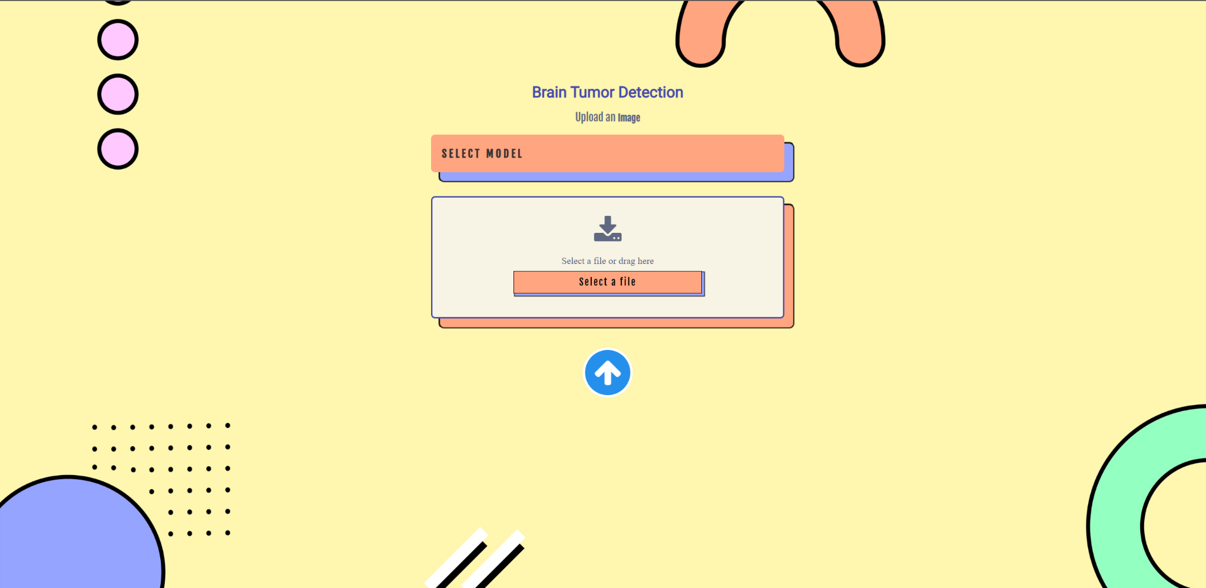

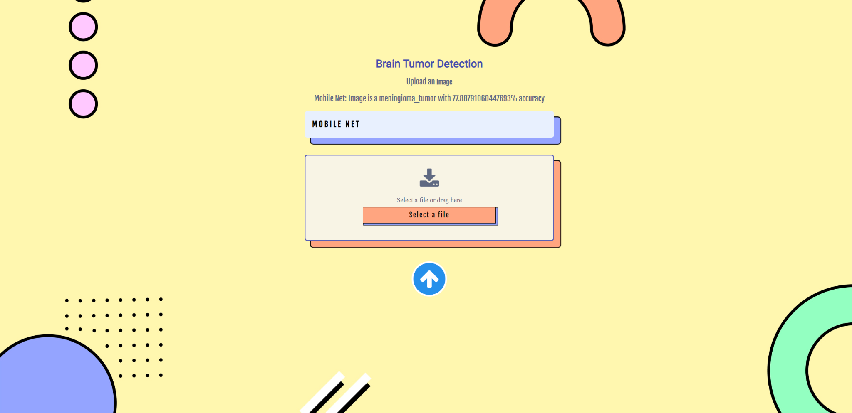

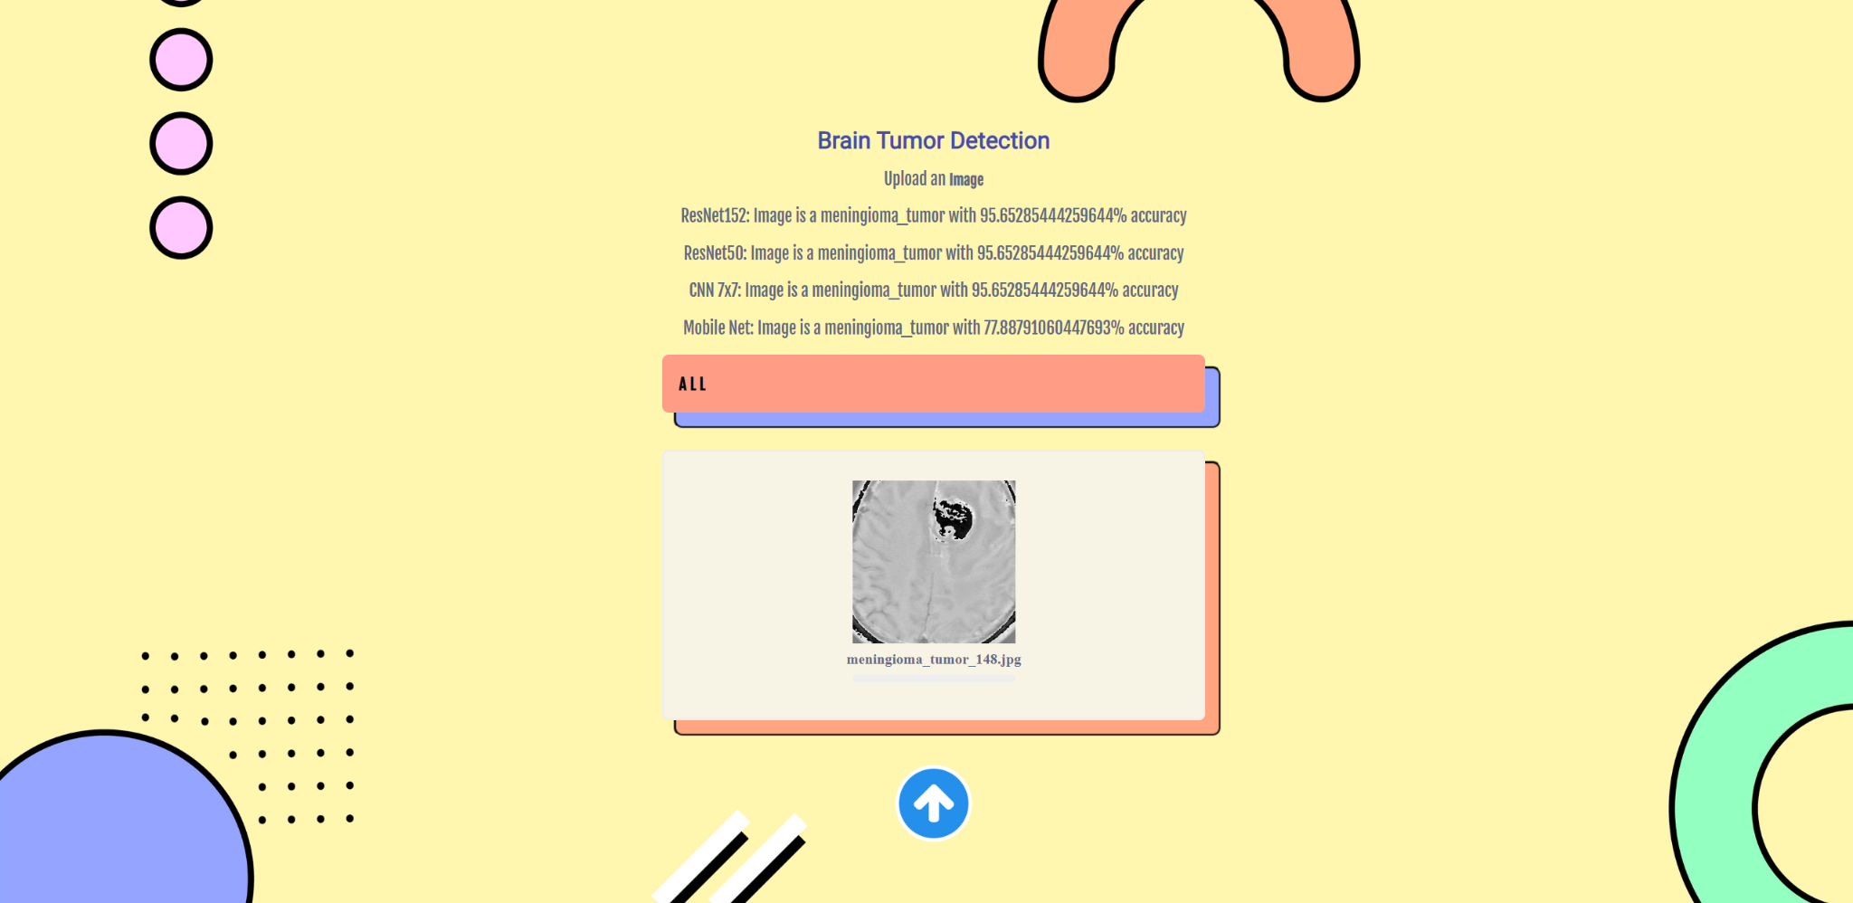

**4.3 EXPERIMENTAL RESULTS:**

**CNN 7x7 results:**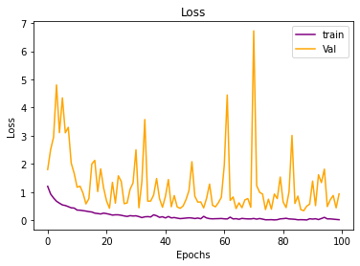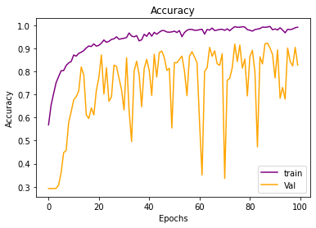

**MobileNet results:**

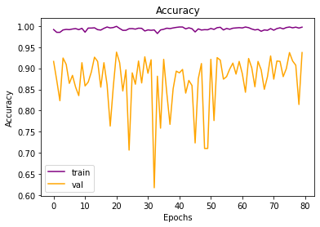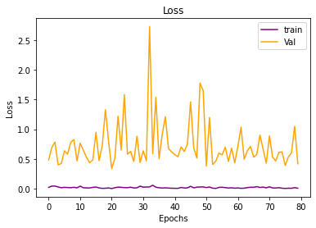

**ResNet 50 results:**

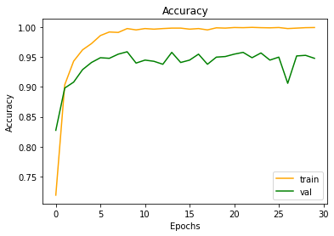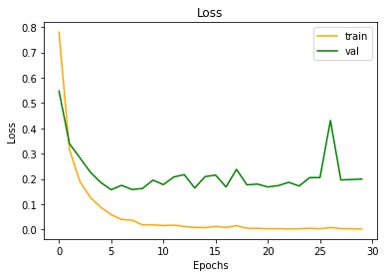

**ResNet 152 results:**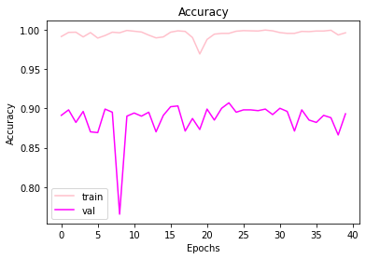

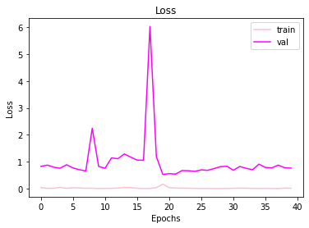

**Comparison between all models:**

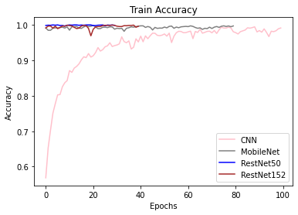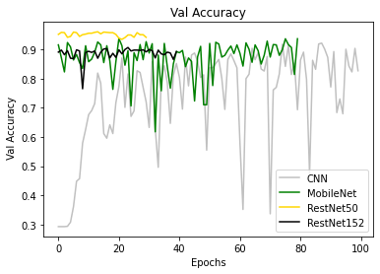

**4.4** **PERFORMANCE MEASURES:**

The proposed algorithm has undergone comprehensive evaluation using various performance metrics. These metrics include True Positive and True Negative. True Positive refers to the algorithm's ability to correctly identify damaged regions as damaged, while True Negative signifies its correct identification of non-damaged regions as non-damaged. Additionally, This system False Positive (FP) and False Negative (FN). FP represents the algorithm's failure to recognize damaged regions accurately, and FN represents its failure to identify non-damaged regions correctly.

Based on the values of TP, TN, FP, and FN, we can calculate the Accuracy,Specificity, and Sensitivity of the proposed algorithm:

* Accuracy: This metric determines the overall correctness of the algorithm's predictions and is calculated as (TP + TN) / (TP + TN + FP + FN).
* Specificity: It measures the algorithm's ability to correctly identify non-damaged regions and is calculated as TN / (TN + FP).
* Sensitivity: Also known as Recall or True Positive Rate, it indicates the algorithm's ability to correctly identify damaged regions and is calculated as TP / (TP + FN).

**4.5 PERFORMANCE EVALUATION:**

In medical imaging tasks, both convolutional neural networks (CNNs) and residual networks (ResNets) can be effective for tasks such as image classification and segmentation. However, ResNets are generally considered to be better suited for

medical imaging tasks because they are able to handle the large amount of data that is typically present in these tasks, and they are able to effectively learn complex patterns in the data. MobileNets, on the other hand, are not as well-suited for

medical imaging tasks because they are designed to be more efficient than other CNNs, which means they have fewer parameters and require less computational power. This makes them better suited for use on mobile and other resource-

constrained devices, but it also means that they may not be as accurate as ResNets for medical imaging tasks. The above is the usual trend and we can also see it being satisfied while being trained as ResNets get us the highest training accuracy whereas MobileNet here gets the higher validation accuracy. This means that the complexity of the network in this problem does not necessarily translate to a

better performing model. We are able to get better performance from a simpler model as it is able to generalize better and perform well on the test set.

|  |  |  |  |  |
| --- | --- | --- | --- | --- |
| Network | Train | Test | Val | Epoch |
| Conv | 99% | 78% | 92% | 100 |
| Mobile | 99% | 78% | 92% | 100 |
| Res50 | 100% | 77% | 95% | 30 |
| Res152 | 99.1% | 71% | 90.2% | 40 |

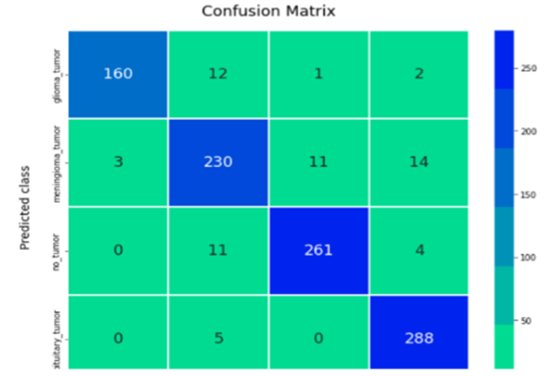

**Fig: Confusion Matrix**

**CHAPTER 5**

**RELATED WORKS**

There have been several related papers and projects to the project of using deep neural network technology to identify tumors in the brain. Some notable examples include:

1. In the project titled "Brain Tumor Detection with Deep Learning" by Pritom Das Radheshyam, advanced techniques based on deep learning are employed to identify brain tumors from MRI scan images. Specifically, a combination of Residual Network and Convolutional Neural Networks (CNNs) is utilized. This innovative approach enhances the efficiency and precision of detecting and localizing brain tumors based on MRI scans.
2. In the project titled "Brain Tumor Detection with Deep Learning" by Pritom Das Radheshyam, advanced techniques based on deep learning are employed to identify brain tumors from MRI scan images. Specifically, a combination of Residual Network and Convolutional Neural Networks (CNNs) is utilized. This innovative approach enhances the efficiency and precision of detecting and localizing brain tumors based on MRI scans.
3. In the project titled "Brain Tumor Detection with Deep Learning" by Pritom Das Radheshyam, advanced techniques based on deep learning are employed to identify brain tumors from MRI scan images. Specifically, a combination of Residual Network and Convolutional Neural Networks (CNNs) is utilized. This innovative approach enhances the efficiency and precision of detecting and localizing brain tumors based on MRI scans.
4. In the project titled "Brain Tumor Detection with Deep Learning" by Pritom Das Radheshyam, advanced techniques based on deep learning are employed to identify brain tumors from MRI scan images. Specifically, a combination of Residual Network and Convolutional Neural Networks (CNNs) is utilized. This innovative approach enhances the efficiency and precision of detecting and localizing brain tumors based on MRI scans.

**CHAPTER 6**

**CONCLUSION AND FUTURE WORK**

**6.1 CONCLUSION**

Upon testing the dataset with above frequencies, the model was able to classify images from the test dataset to the maximum of 80%. Although there are plenty of scopes of improvement, one of the major scope of improvement would be implementation of better data augmentation techniques and also inclusion of redundancy blocks in deeper convolute networks. Thus a comparative study of various models to classify brain tumors has been studied and implemented including a custom model and three pretrained models. It is observable that pretrained models with custom changes are providing good scopes for MRI Images and thus generalizing the model to a greater extent for medical usages. By using the Augmentation cropping we were able to achieve a model with higher accuracy.

**6.2 FUTURE WORK**

In the process of tackling a challenging problem like tumor detection in medical image processing, it has become evident that the existing approach requires a large training dataset to achieve more accurate results. However, gathering such medical data is a daunting and time-consuming task, and sometimes the necessary datasets are simply not available. This poses a significant hurdle for the proposed algorithm, as it must be able to robustly and accurately identify tumor regions from MR images even in data-scarce scenarios. To address this issue and improve the proposed approach, there are a couple of potential strategies to consider. Firstly, incorporating weakly trained algorithms could prove beneficial, as they have the ability to identify abnormalities with minimal training data. These algorithms might not require an extensive amount of labeled examples to achieve reasonable performance. Additionally, integrating self-learning algorithms into the process could greatly enhance the accuracy of the algorithm while also reducing computational time. Self-learning algorithms have the capability to learn from the data itself, continuously improving their performance over time without relying solely on pre-existing labeled data. By implementing these approaches, we can aim to overcome the limitations imposed by scarce training data in medical image processing, allowing for more robust and accurate tumor recognition from MR images.